

**Capstone Project Report**

**Report 1 – Project Introduction**

– Hanoi, August 2019 –

**Table of Contents**

I. Project Report 3

1. Status Report 3

2. Team Involvements 3

3. Issues/Suggestions 3

II. Project Introduction 4

1. Overview 4

1.1 Project Information 4

1.2 Project Team 4

2. Product Background 4

3. Existing Systems 4

3.1 System name1 4

3.2 System name2 4

4. Business Opportunity 5

5. Software Product Vision 5

6. Project Scope & Limitations 5

6.1 Major Features 5

6.2 Limitations & Exclusions 6

# I. Project Report

## 1. Status Report

|  |  |  |  |
| --- | --- | --- | --- |
| **#** | **Work Item** | **Status** | **Notes (Work Item in Details)** |
| 1 |  | Pending |  |
| 2 |  | In Progress |  |
| 3 |  | Completed |  |

## 2. Team Involvements

|  |  |  |  |
| --- | --- | --- | --- |
| **#** | **Task** | **Member** | **Notes (Task Details, etc.)** |
| 1 |  | KienNT |  |
| 2 |  | TuanTV |  |
| 3 |  | AnhLM |  |

## 3. Issues/Suggestions

|  |  |  |  |
| --- | --- | --- | --- |
| **#** | **Issue** | **Status** | **Notes (Solution, Suggestion, etc.)** |
| 1 |  | Pending |  |
| 2 |  | In Progress |  |
| 3 |  | Completed |  |

# II. Project Introduction

## 1. Overview

### 1.1 Project Information

* Project name: << Cafeteria Ordering System>>
* Project code: <<COS>>
* Group name: <<SWP493-G4>>
* Software type: <<Software Type: Web, Mobile App,..>>

### 1.2 Project Team

#### a. Supervisor

|  |  |  |  |
| --- | --- | --- | --- |
| **Full Name** | **Email** | **Phone Number** | **Title** |
| Nguyen Trung Kien | kiennt@fe.edu.vn | 0912656836 | Lecturer |

#### b. Team Members

|  |  |  |  |
| --- | --- | --- | --- |
| **Full Name** | **Email** | **Mobile** | **Role** |
| Nghiem Thi Thuy Van |  |  | Leader |
| Dam Thi Huyen |  |  | Member |
| Dao Thi Phuong |  |  | Member |
| Vu Thi Thuy |  |  | Member |

## 2. Product Background

*[This section summarizes the rationale for the new product. Provide a general description of the history or situation that leads to the recognition that this product should be built. You should also mention here the information on the customer /the people who raise project idea/request]*

<<Sample: Employees at the company Process Impact presently spend an average of 65 minutes per day going to the cafeteria to select, purchase, and eat lunch. About 20 minutes of this time is spent walking to and from the cafeteria, selecting their meals, and paying by cash or credit card. When employees go out for lunch, they spend an average of 90 minutes off-site. Some employees phone the cafeteria in advance to order a meal to be ready for them to pick up. Employees don’t always get the selections they want because the cafeteria runs out of certain items. The cafeteria wastes a significant quantity of food that is not purchased and must be thrown away. These same issues apply to breakfast and supper, although far fewer employees use the cafeteria for those meals than for lunch.>>

## 3. Existing Systems

[Add the system which might help solving the problems you listed above or the systems in which you can learn/refer the features for your system design]

### 3.1 System name1

[Write the brief descriptions of the system, the link, the system actors, features, pros, cons, etc.]

### 3.2 System name2

…

## 4. Business Opportunity

*[Describe the market opportunity that exists or the business problem that is being solved. Describe the market in which a commercial product will be competing or the environment in which an information system will be used. This may include a brief comparative evaluation of existing products and potential solutions, indicating why the proposed product is attractive. Identify the problems that cannot currently be solved without the product, and how the product fits in with market trends or corporate strategic directions]*

<<Sample: Many employees have requested a system that would permit a cafeteria user to order meals (defined as a set of one or more food items selected from the cafeteria menu) on line, to be picked up at the cafeteria or delivered to a company location at a specified time and date. Such a system would save employees time, and it would increase the chance of their getting the items they prefer. Knowing what food items customers want in advance would reduce wastage in the cafeteria and would improve the efficiency of cafeteria staff. The future ability for employees to order meals for delivery from local restaurants would make a wide range of choices available to employees and provide the possibility of cost savings through volume discount agreements with the restaurants.>>

## 5. Software Product Vision

*For businesses that need to manage information about customers and information about marketing and sales, the CRMP system is an internet-based application that will help businesses manage this information right at the first time when customers arrive business connection. Salespeople of the business will approach existing customers or create their own contacts, leads and start tracking interactions with customers, at the same time the system will also summarize and report necessary data back for businesses and managers such as: Sales activities with customers and vice versa, quantity of goods sold, areas where customers have purchased, customer interaction and interest goods, etc. Unlike today's manual sales management processes, business owners and employees using a CRMP system will have a complete view of the data that has been realized on the application. This will help businesses save time in management and make the right decisions in the future of the business.*

<<**Vietnamese**: Đối với những doanh nghiệp cần quản lý thông tin về khách hàng và thông tin về tiếp thị và bán hàng, hệ thống CRMP là ứng dụng trên nền tảng internet sẽ giúp doanh nghiệp quản lý những thông tin này ngay từ lần đầu tiên khi khách hàng kết nối với doanh nghiệp. Người bán hàng của doanh nghiệp sẽ tiếp cận khách hàng đã có sẵn hoặc tự tạo cho mình những liên hệ, leads và bắt đầu theo dõi tương tác với khách hàng đồng thời ngay lúc đó hệ thống cũng sẽ tổng hợp và báo cáo lại các dữ liệu cần thiết cho doanh nghiệp và nhân viên quản lý như: Những hoạt động của sale với khách hàng và ngược lại, số lượng hàng hóa đã bán được, khu vực khách hàng đã mua, mức độ tương tác và quan tâm của khách hàng, v.v. Không giống như các quy trình quản lý bán hàng thủ công ngày nay, chủ doanh nghiệp và nhân viên sử dụng hệ thống CRMP sẽ có cái nhìn toàn diện về dữ liệu đã được hiện thực trên ứng dụng. Điều này sẽ giúp doanh nghiệp tiết kiệm thời gian trong việc quản lý và đưa ra các quyết định đúng đắn trong tương lai của doanh nghiệp.>>

## 6. Project Scope & Limitations

*[The project scope defines the concept and range of the proposed solution. It’s also important to define what will not be included in the product. Clarifying the scope and limitations helps to establish realistic expectations of the many stakeholders. It also provides a reference frame against which proposed features and requirements changes can be evaluated. Proposed requirements that are out of scope for the envisioned product must be rejected, unless they are so beneficial that the scope should be enlarged to accommodate them (with accompanying changes in budget, schedule, and/or resources)]*

### 6.1 Major Features

*[Include a numbered list of the major features of the new product, emphasizing those features that distinguish it from previous or competing products. Specific user requirements and functional requirements may be traced back to these features.]*

<<Sample:

FE-01: Order and pay for meals from the cafeteria menu to be picked up or delivered.

FE-02: Order and pay for meals from local restaurants to be delivered.

FE-03: Create, view, modify, and cancel meal subscriptions for standing or recurring meal orders, or for daily special meals.

FE-04: Create, view, modify, delete, and archive cafeteria menus.

FE-05: View ingredient lists and nutritional information for cafeteria menu items.

FE-06: Provide system access through corporate intranet, smartphone, tablet, and outside Internet access by authorized employees

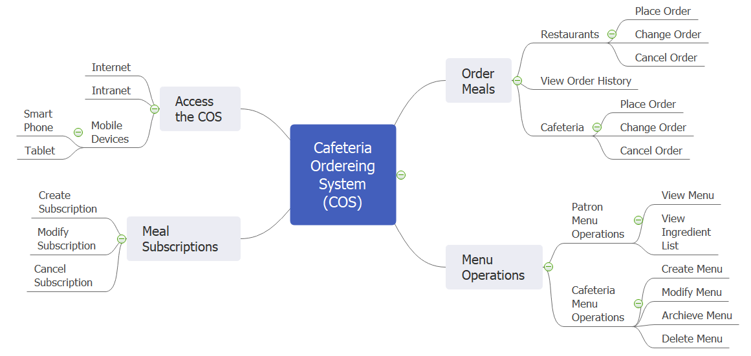

>>

### 6.2 Limitations & Exclusions

*[Identify any product features or characteristics that a stakeholder might anticipate, but which are not planned to be included in the new product.]*

<<Sample:

LI-1: Some food items that are available from the cafeteria will not be suitable for delivery, so the menus available to patrons of the COS must be a subset of the full cafeteria menus.

LI-2: The COS shall be used only for the cafeteria at the Process Impact campus in Clackamas, Oregon.

>>